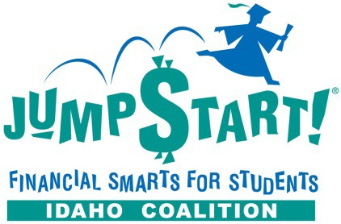

2021 NEC Teacher Scholarship Contest
The Idaho Financial Literacy Coalition, the Idaho Affiliate of Jump$tart Financial Smarts for Students, is proud to offer scholarship opportunities for Idaho educators to attend the Jump$tart National Educator Conference, November 6-8, 2021 in Washington D.C..

Who can apply?

This contest is open to all Idaho K-12 educators who teach personal finance, consumer finance, economics or closely related courses. Academic administrators are welcome to apply, but please note the nature of your position and its relationship to financial education on your application.

Two teachers will be awarded a scholarship.

Scholarships include:

- $1250 registration fee covered 100% by National Jumpstart. This includes two-night stay at conference hotel, and all conference meals and materials
- $1000 travel and expense stipend covered by the Idaho Financial Literacy Coalition
- 15 Professional Hours
Travel expenses will be reimbursed upon return, with submission of receipts.
For more information on the conference:
http://jumpstart.org/nec.html

Application requirements:

Complete, sign and submit the following application to the Idaho Financial Literacy Coalition (information@idahoflc.org).

Applications must be received by Wednesday, June 30, 2021. Winners will be contacted by Friday, August 20, 2021.

Those selected to attend the National Educator’s Conference are asked to attend the Coalition’s member meeting afterwards to give a 10 to 15-minute presentation about your conference experience. The meeting will be in Boise, ID, November 17, 2021 3:00 PM - 4:00 PM.

Please answer each question fully; incomplete applications will not be processed.

Applicant information:

Name: | Click here to enter text.
Email address: | Click here to enter text.
Telephone number: | Click here to enter text.
Mailing address: | Click here to enter text.

School information:

School name: | Click here to enter text.
School’s physical address: | Click here to enter text.
School’s principal/administrator | Click here to enter text.

What subject(s) do you teach?
Click here to enter text.

How do you incorporate economic or financial education into the courses you teach?

Click here to enter text.

How many students will benefit from economic or financial education in your classroom throughout the school year?
Click here to enter text.

Please share an example of an innovative method you’ve used in your classroom to teach personal finance or economics. Please describe how you judged its effectiveness.
(200-500 words)

Click here to enter text.

If chosen to attend the National Educator Conference, would you be willing to serve on an advisory committee for the Idaho Jump$tart Coalition?
Click here to enter text.

How will you and/or your school benefit from attending the Educators Conference?
Click here to enter text.

Additional comments: (optional)
Click here to enter text.

Certification:

By signing this application I,Click here to enter text. certify that:

  - I’ve completed this application accurately and to the best of my knowledge.
  - If chosen, I will use the travel stipend to help cover the costs associated with the Jump$tart National Educator Conference.
  - I give the Idaho Financial Literacy Coalition and/or its designee’s permission to use my name, comments and/or photographs for advertising and promotional purposes on its website and/or printed materials. I understand I will receive no compensation for the use of my picture and/or name.

Click here to enter a date.

Signature Date

